# Signal Analysis

|  |  |
| --- | --- |
| *τ0* | The decay time constant calculated in aerosol free air. In the software, this value is referred to as **tau0**. Both this value and the one described below are averaged over the entire period the flow is filtered. In each case, the first five shots are disregarded during the filter period as these values may be influenced by aerosol obtained prior to the switch from sample flow to filtered flow.  Both $τ_{0}$ and the corrected value are averaged while the instrument samples on filter. The time over which the sample is acquired is variable, but the default is 5 seconds. Practically, we remove the last data point sampled before the filter change (back to sample) to avoid any anomalous data points |
| *τ0’* | The decay time constant calculated in aerosol free air corrected for Rayleigh scattering. This value in *μ*s is obtained using the following formula: $${\left(τ_{0}^{-1}-\left[\left(1×{10}^{6}×M-N_{ref}\right)×c×c_{ext}\right]\right)}^{-1}×{10}^{6}$$ |
| *cext* | Extinction cross section. |
| *c* | Speed of light in m/s. This value is assumed constant at 2.99792×108. |
| *M* | Molecular density of air in number per cm3. This value is calculated as a function of temperature and pressure: $$\frac{P}{T×k}×{10}^{-6}$$ where *P* is in Pascals and T is in Kelvin. |
| *k* | Boltzman’s constant; 1.38065×10-23 J/K |
| *λ* | Wavelength of light in nm. This value is denoted in the software as **lambda**. |
| *σext* | Extinction in Mm-1. This value is calculated as $$r×f_{dil,ext}×\left(\frac{1}{τ^{'}}-\frac{1}{τ_{0}^{'}}\right)$$ where the time constants corrected for Rayleigh scattering are in s (as opposed to *μ*s). |
| *r* | An optical time constant that is defined by the length of the cavity and is determined empirically. This value in the software is called **optTimeConst**. |
| $$p$$ | Position of cell in a bank of cells connected in series. |
| $$f_{dil,ext}$$ | An extinction dilution factor that is a function of the position of the cell relative to other cells in series and the mirror purge flow rate, *Qpurge*.  where *z* is $2×p-p$. |
| $$x$$ | The total number of cells in a bank of cells connected in series multiplied by a factor of 2. |
| $$y$$ | Total number of cells in the system multiplied by a factor of 2 (this is the total number of ways the purge flow is divided into). |
| $$f_{dil,V}$$ | Volume dilution factor. This factor is used to correct the RH and flow rate measurements (made at the end of a cell) for the introduction of purge flows in each cell. $$1-\left(y+2p+1\right)×\frac{Q_{p}}{Q_{f}}$$ |
| $$Q_{f}$$ | The final flow measured at the end of a series of connected cells. This value must be corrected in each cell to correctly get the flow rate (although, at small flow rates, the difference may be insignificantly small). |
| $$Q_{p}$$ | Purge flow rate. In each cell, the purge flow is used to prevent contamination of mirrors at either end and is therefore introduced at two points in the cell. |
|  |  |
|  |  |
|  |  |
|  |  |
|  |  |
|  |  |
|  |  |

*τ0* – the decay time constant calculated in aerosol free air. In the software, this value is referred to as **tau0**

# Configuration

## Flow Configuration

|  |  |  |  |
| --- | --- | --- | --- |
| MFC | Description | Address | Position |
| Purge | Purge flow is divided 8×2 ways for keeping the mirrors uncontaminated | A | 1 |
| Thermodenuded | Two channels that travel through the thermodenuder; red/blue – flow travels through red first (cell 2) | J | 2 |
| Dry | Four channels; blue, blue, red, green; first channel flow travels through is the green (cell 6). The final channel is the first blue and is filtered (gas reference). | I | 3 |
| Medium RH | Green; cell 7 | H | 4 |
| High RH | Green; cell 8 | G | 5 |

## DAQmx Configuration

### Housekeeping

All housekeeping is performed on the PXI-6225 card (which occupies slot 8 in the chassis). The signals are acquired at a rate of 100 Hz and averaged over a 1 Hz period. During acquisition, signals are acquired consecutively (as opposed to concurrently as with the S-series cards). The signals are assumed not to vary significantly over time scales greater than 1 s.

### Photodiode Acquisition

Data from the photodiodes on the CRDS is acquired at high frequency using the PXI-6133. On this card, we can acquire at rates up to 2.5 MS/s/ch *simultaneously*. In the case of the CRDS, the rate of acquisition is 2-2.5 MS/s/ch with acquisition occurring only when the pulse on the YAG counter output is high. In this manner, the YAG counter is output onto an internal counter which in turn is connected to a trigger line on the PXI backplane (PXI_Trig0). This line is further connected to a counter on the acquisition card (ctr0) which operates at the desired acquisition frequency. When the trigger line on the backplane is high, the counter runs; when it is low, the counter is paused. In this way, we may control the timing of the acquisition such that we do not have to sort the data before operating on the acquired photodiode data.

## TEC Humidity Control

In the last two cells, the humidity may be controlled via two saturators located upstream of the cells. Each saturator consists of a single length of Permapure tubing which is filled with water in the outer annular region. The

P = 0.14

I=4.73

D = 1.18

## U Drive

If you so desire, the ability to write taus (all 8k a second) is now available. The updated interface will contain a new indicator which will tell the user whether a properly formatted jump drive is available (this is called U). If it is, then the taus will automatically begin writing to a file under a folder labeled by date. For each file generated (one will be generated each time the drive is connected or disconnected), the title of the file will be tausyyyyddmm_hhmmss.bin (I think). In order to properly remove the disk without the danger of corruption to the file, the disk must be properly ejected. In order to do this, select File->Eject U Drive on the interface. Once the disk is "ejected", then this option is grayed out and the drive is no longer being written to.

A couple of things to keep in mind:

* The drive is hot-swappable (meaning you can take it out or put it in at any point), just remember to eject the disk first so that nothing bad happens.
* You are writing 8k floating point samples a second to disk. This translates to roughly 32 kb/s, or > 1 Mb/min. Currently there are no checks to make sure you are not writing past the capacity of the disk, so make sure you size your disk appropriately for the amount of time you plan to have it connected.
* The data is saved as:
  + Time (dbl precision)
  + Array size (32-bit int)
  + Array of floats (each 32-bit)
* The disk used to save data must be formatted as FAT. It will be very evident on the user interface if it is not as the drive will not be indicated as connected.
* Every time the drive is accessed, there will be a file with a time that the drive was initially accessed called 'status_check.txt'. I use this file to monitor the connection status of the drive. Don't worry about this file, just expect to see it as I don't clean it up currently.

## Data File Format

|  |  |  |  |
| --- | --- | --- | --- |
| ID | Name | Array? | Format |
| 0 | Time | No | Dbl |
| 1 | RHw |  |  |
| 2 | TRH |  |  |
| 3 | P |  |  |
| 4 | Tmean |  |  |
| 5 | RHsense |  |  |
| 6 | TQ |  |  |
| 7 | PQ |  |  |
| 8 | Q |  |  |
| 9 | Q0 |  |  |
| 10 | Qsp |  |  |
|  |  |  |  |
|  |  |  |  |
|  |  |  |  |

# General

## Filter Settings

There are currently two modes to how the filter may cycle. The first is manual. In this case, the filter must be manually switched back and forth by the user. In the second mode, the user has no control over the filter position directly. When the mode is switched from manual to auto-cycling, the position of the flow is immediately set to filter. The flow remains in this configuration for a time defined on the configuration screen (Tools->Configuration) and then switches to the sample stream (i.e. the flow is diverted from the filter).

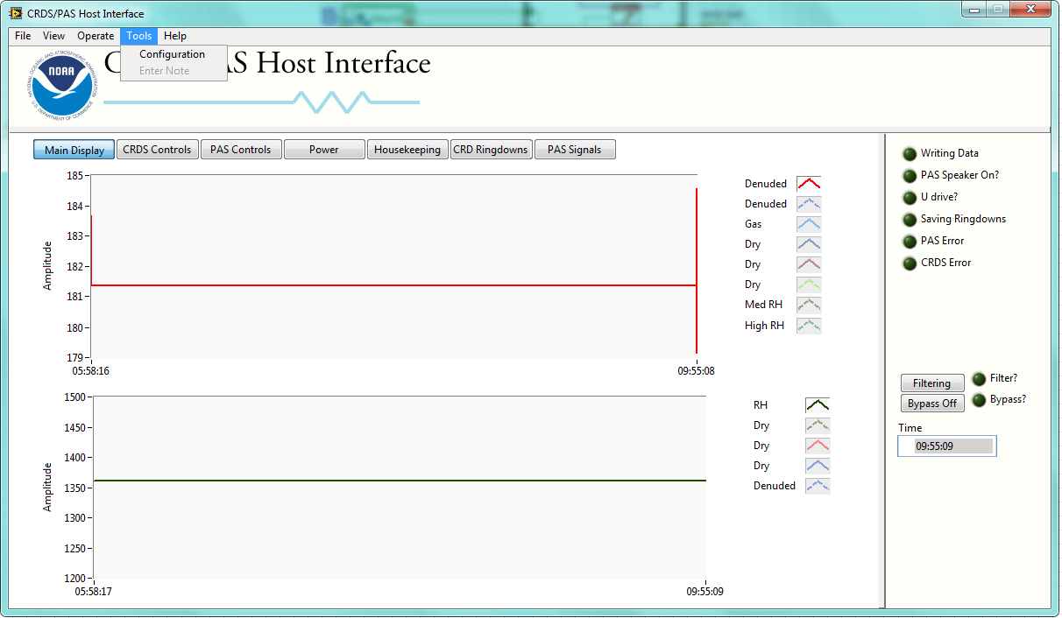

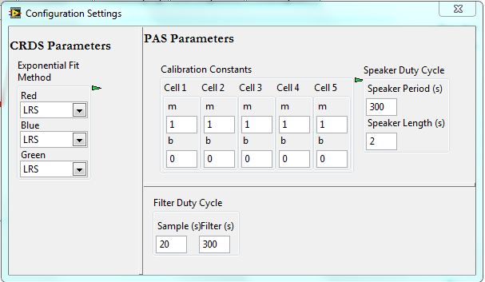

## Humidity Control

In both the PAS and the CRDS, there are channels in which the humidity is to be actively controlled. In the PAS, this corresponds to the first channel and the relative humidity is to be maintained in the cell at $\sim 80\%$. In the CRDS, there are two cells which we will operate at two distinct temperatures – cells 7 and 8. In these cells, the RH will be maintained at $\sim 75\%$ and $>85\%$. In each case, we desire to maintain the relative humidity in the cell of interest within $\sim 1\%$.

To control the humidity, sample air is passed through a block for which the temperature is actively controlled using a thermoelectric cooler (TEC; Wavelength Electronics, WTC3243). The sample passes through a line in the block which contains a Permapure humidifier. The humidifier consists of two concentric tubes – the outer is stainless steel while the inner is a Nafion. The sample passes through the Nafion tubing. Water contained in the annular region created by the two tubes provides the water vapor source for humidification. The amount of water vapor in the sample air is controlled primarily by the humidifier temperature.

The temperature is controlled via an input voltage signal representing the desired temperature. The voltage itself is twice the thermistor resistance at the given temperature. The thermistor which provides the feedback to the TEC is the ON-930-44006 which provides a resistance of 10 kΩ at 25°C. Conversion of the temperature to a resistance is based on the Steinhart-Hart equations and is:

$$R=\text{exp}\left(\sqrt[3]{x-\frac{y}{2}}-\sqrt[3]{x+\frac{y}{2}}\right)$$

where

$$y=\frac{\left(A-\frac{1}{T}\right)}{C}$$

and

$$x=\sqrt{{\left(\frac{B}{3C}\right)}^{3}+\frac{y^{2}}{4}}$$

In the above equations, the coefficients are defined by the Steinhart-Hart equations for the given thermistor and are $A=1.02919e^{-3}$, $B=2.39128e^{-4}$, and $C=1.56628e^{-7}$.

Table 1. TEC PI gain values.

|  |  |  |
| --- | --- | --- |
|  | Gains (with R in parentheses) | |
| Device | P | I |
| PAS | 50 (50 kΩ) | 0.53 (open) |
| CRDS | 10 (10 kΩ) | 0.53 (open) |

Once the temperature setpoint is provided to the controller, the TEC then uses a PI algorithm to control to maintain the temperature at the desired setpoint. The gains for the proportional and integral terms of the controller are set via resistors in hardware. As of April 2012, prior to deployment for DC3, all controllers were operating with the integral portion of the circuit open. The values of the proportional resistors are 50 kΩ for the PAS and 10 kΩ for the two CRDS saturators. Using equations provided by Wavelength Electronics, this gives gains of approximately 50 and 10 for the saturator TECs respectively. With the open integral circuit, the gain for the integral term is 0.53. All values are outlined in Table 1.

If the saturator efficiency were 100% (i.e. the relative humidity at the outlet of the saturator were 100%, after adjusting for temperature), then all that would be necessary would be to set the temperature of the saturator to achieve the user defined relative humidity at the cell temperature based on the Clausius-Clapyeron equations. However, the relative humidity in the cell will ultimately be defined by other parameters such as flow rate, pressure, environmental temperature, etc that may not be easily accounted for. Because of these parameters, we use an in-software PID algorithm to control the relative humidity.

In the software, the relative humidity from the Vaisala probe in the cell in which we are trying to control humidity is provided to the Labview PID routine. The error signal is then calculated as $e= RH_{set}-RH_{meas}$. Using the error, the output of the PID controller is calculated as

$$u\left(t\right)=K_{c}\left[e+\frac{1}{T_{i}}\int_{0}^{t}{e dt}-Td\frac{dRH_{meas}}{dt}\right]$$

Here, $RH_{meas}$ is substituted for $e$ in the derivative term to avoid derivative kick due to abrupt changes in the setpoint value. Here, the integration and derivation are performed over the period $t$, which for the current use is set to 2 s. From the above implementation of the PID algorithm in Labview, it is clear that the proportional gain ($K_{c}$) has a direct impact on the integral ($K_{c}/T_{i}$) and derivative ($-K_{c}×T_{d}$) terms. The output of this equation is 0 to 100%.

Once the value $u(t)$ is calculated, it is then translated to a temperature. For the purposes of saturator control, we confine the temperature between air temperature (or dew point of the air $T_{d}$ in the cell as specified by the user) and a minimum temperature defined by

$$T_{min}=2T_{sat}-T_{air}$$

where the value $T_{sat}$ is the saturator setpoint for a given RH. Since the air enters the saturator at a warmer temperature than the saturator, the air entering must also be cooled by the saturator. As it is unlikely that the air is cooled to the final TEC temperature setpoint, the air temperature exiting will likely be some combination of the air inlet and TEC temperature. Given this, information, if we wish to hit the RH based on a theoretical calculation of temperature, we will have to drive the temperature of the saturator even lower. The worst case scenario is that the outlet temperature will be the average of the inlet temperature and the TEC temperature.

Using this, we can calculate the minimum temperature in the target range as above. While this gives us a lower minimum than we likely need (we can probably start with a $T_{min}$ of the theoretical temperature setpoint given that the required saturator temperature is likely to be higher than this), it still provides a reasonable range over which to adjust the temperature setpoint. Finally, the controller output then corresponds to $T_{min}$ at 0% and $T_{max}$ at 100%. Using this algorithm, as of April 2012 prior to the deployment for DC3, the PID parameters for the PAS controller was 5,1,2 and those for the CRDS were 10,1,2.

# PAS Signals

## Speaker

For calibrating the resonance features of the PAS cells, we go through the cycle shown in Figure 1. At a rate of 1 Hz, a “chirp” is emitted from a speaker located in the PAS cavity. This “chirp” is a wave which produces a tophat like structure in the frequency domain. In the current configuration,

In physics, the Lorentzian distribution describes forced resonance. For the photoacoustic, we use the Lorentzian to characterize the speaker signal via the retrieved power spectrum (this will be the square of the amplitude, or $C^{2}=A^{2}+B^{2}$, where $A$ is the coefficient of the real terms in the FFT and $B$ is the coefficient for the imaginary terms). The Lorentzian function is defined as

$$L\left(f\right)=a_{0}+\frac{a_{1}}{\left(f-a_{2}\right)+a_{3}}$$

where $f$ is the frequency, $a_{0}$ is an offset attributable to a constant background noise (be it electronic or acoustic in nature), and $a_{2}$ is the resonant frequency $f_{0}$, or the median of the distribution where the function is at a max. From these values, the max may be calculated as

$$\text{max}\left(L\right)=\frac{a_{1}}{a_{3}}$$

and the full width half maximum ($FWHM$) is solved using the above equations and can be written as

$$FWHM=2\sqrt{a_{3}}$$

This value holds regardless of the offset in the distribution $a_{0}$. From these values, we have the resonant frequency $a_{2}$ and can calculate the quality of the resonance

$$Q=\frac{f_{0}}{FWHM}=\frac{a_{2}}{2\sqrt{a_{3}}}$$

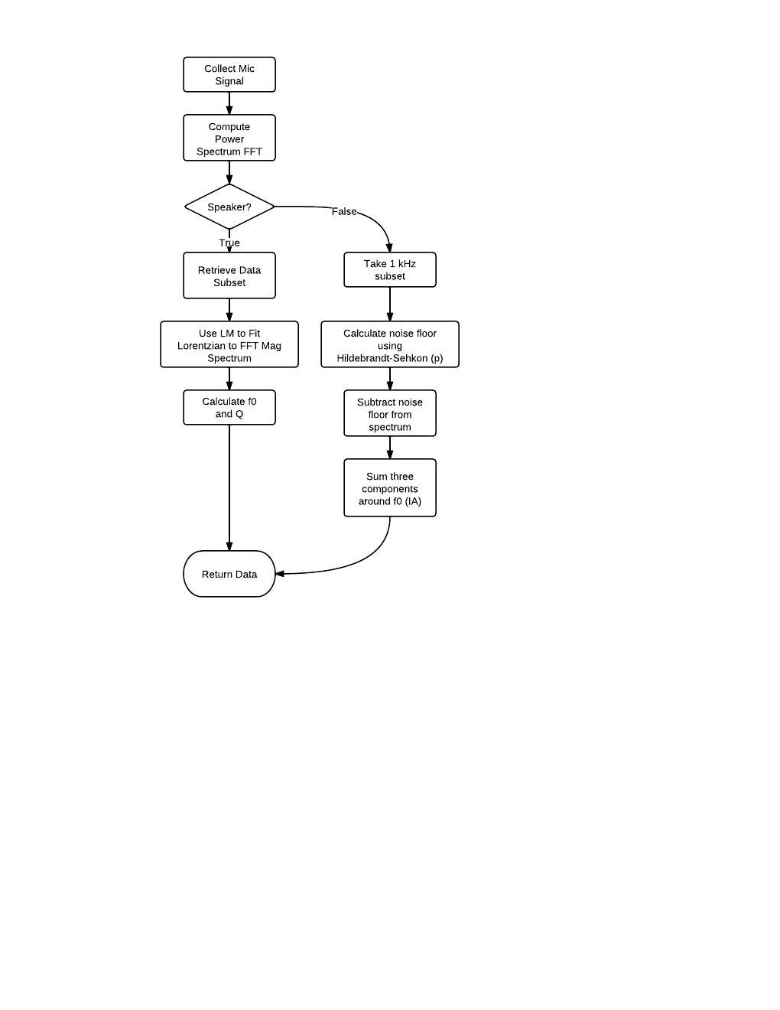

Figure 1. Microphone analysis flow.

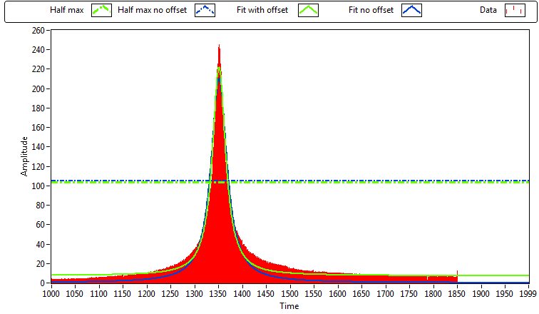

Figure 2. Speaker Analysis - 800 Hz range.

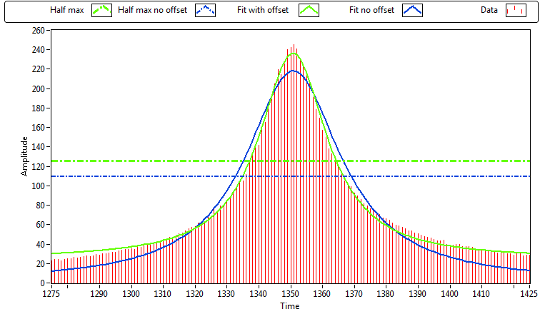

Figure .

